**SAVEETHA SCHOOL OF ENGINEERING**

**CAPSTONE PROJECT**

**"IP Addressing and Subnetting with VLAN Configuration for Network Routing and Connectivity Across Multiple Locations"**

**NAME:** Avinaash A

**REGISTER NUMBER:** 192324260

# COURSE CODE: CSA0747

**COURSE NAME:** Computer Network for IOT

**INTRODUCTION:**

This project focuses on implementing IP addressing, subnetting, and VLAN configuration across LAN, MAN, and WAN networks using Cisco Packet Tracer. An appropriate IP range will be allocated and divided into subnets, followed by router configuration for RIPv2 routing between subnets. VLANs will be set up to logically separate departments, enhancing security and performance. Finally, comprehensive testing will validate connectivity and routing across the network.

**LITERATURE REVIEW**

IP addressing and subnetting are crucial for network management, ensuring device identification and efficient use of IP resources (Tanenbaum & Wetherall, 2011). Subnetting improves performance by reducing congestion. VLANs, as described by Stallings (2013), allow logical segmentation of networks, enhancing security and traffic control.

Here’s a methodology following the setup we discussed:

### **Methodology**

**Software**:

* Cisco Packet Tracer

**Network Design**:  
The network consists of:

* 3 Routers
* 3 Switches
* 9 PCs
* VLANs configured within the switches for segmentation

**IP Address Allocation**:

### **Step 1**: Setup for **Switch 1** connected to **Router 1**

* **Router 1** IP address (interface connected to Switch 1) - 193.121.56.4
* **PC1** IP address - 193.121.56.1
* **PC2** IP address - 193.121.56.2
* **PC3** IP address - 193.121.56.3

### **Step 2**: Setup for **Switch 2** connected to **Router 2**

* **Router 2** IP address (interface connected to Switch 2) - 193.122.56.4
* **PC4** IP address - 193.122.56.1
* **PC5** IP address - 193.122.56.2
* **PC6** IP address - 193.122.56.3

### **Step 3**: Setup for **Switch 3** connected to **Router 3**

* **Router 3** IP address (interface connected to Switch 3) - 193.123.56.4
* **PC7** IP address - 193.123.56.1
* **PC8** IP address - 193.123.56.2
* **PC9** IP address - 193.123.56.3

### **Step 4**: Router Interconnection

* **Router 1** and **Router 2** connected:
  + **Router 1** (GigabitEthernet 0/1) IP address: 10.0.0.1
  + **Router 2** (GigabitEthernet 0/2) IP address: 10.0.0.2
* **Router 2** and **Router 3** connected:
  + **Router 2** (GigabitEthernet 0/0) IP address: 20.0.0.1
  + **Router 3** (GigabitEthernet 0/1) IP address: 20.0.0.2

### **Step 5**: Configuring Routing Protocols (RIP)

Enable RIP on each router for dynamic routing:

1. Access each router's CLI.
2. Use the following commands for **Router 1**:

plaintext

Copy code

Router1> enable

Router1# configure terminal

Router1(config)# router rip

Router1(config-router)# version 2

Router1(config-router)# network 193.121.56.0

Router1(config-router)# network 10.0.0.0

1. Use similar commands for **Router 2** and **Router 3**, replacing the networks with their corresponding IPs.

**RESULT:**

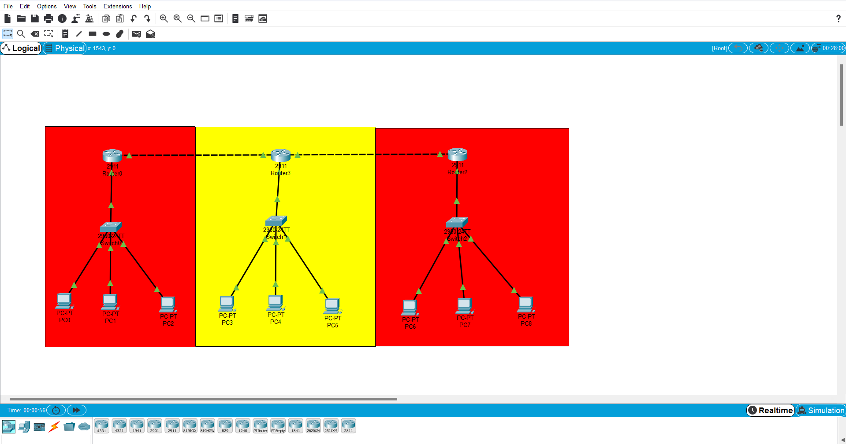

**CONCLUSION:**

n this network setup, we successfully designed a small-scale enterprise network using **Cisco Packet Tracer**, comprising 3 routers, 3 switches, 9 PCs, and a dynamic routing protocol (RIP) for inter-router communication. Each router was assigned a unique IP range for its connected devices, ensuring smooth data flow without conflicts. RIP was implemented to dynamically manage the routing tables between routers, enabling efficient communication between different subnets without the need for static routing.

The use of separate IP address ranges for different routers simulates real-world inter-office or inter-departmental connections in a large company, providing a scalable, secure, and manageable network design. The implementation of VLANs could further enhance traffic segmentation and security. Overall, this network topology demonstrates how internal company networks can be effectively designed to ensure secure, organized, and efficient communication, minimizing reliance on public networks for internal data exchanges.